Information Technology Solutions

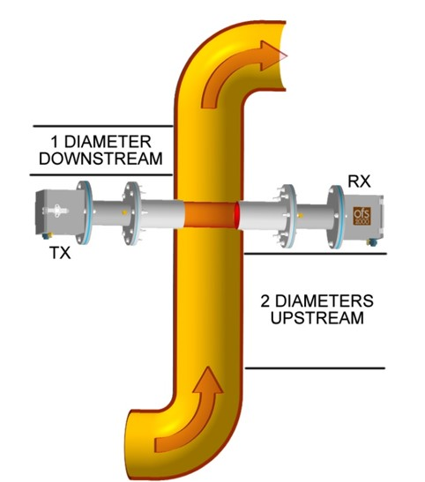
OSi's patented Optical Flow Sensor (OFS) makes drift-free m Optical Scintillationeasurements across the entire stack, duct or pipe diameter and calculates an accurate average flow reading. It is the only flow sensor that gives a true non-contacting cross-stack flow measurement of the process. The OFS uses our EPA Method 14 approved optical scintillation technology. The optical scintillation technique relies on advanced Digital Signal Processing (DSP) electronics to "see" and measure the movement of turbulence found in a gaseous flow stream to provide highly accurate, path-averaged air velocity measurements.
The accuracy of the OFS has been proven both in NIST’s wind tunnel and in numerous real-world installations.

There is an OFS model for nearly any CEMS or process control application.

Industries include Power Plants, Oil & Gas, LNG, Refineries, Chemical,, Steel mills, Pulp & Paper, Glass Plants, Cement, Mining and more.

- OFS provides full cross path measurements
- Non—intrusive measurement (will not create a pressure drop)
- Unaffected by pressure, temperature, moisture, gas density, distance
- Can handle high tempertures
- Stable Technology does not drift
- OFS based on fluctuations of light not absolute light intensity
- 5000/1 turn down extremely slow to extremely Fast flow with one sensor
- No Re-piping Required
- Use for Environmental Compliance and Process Control

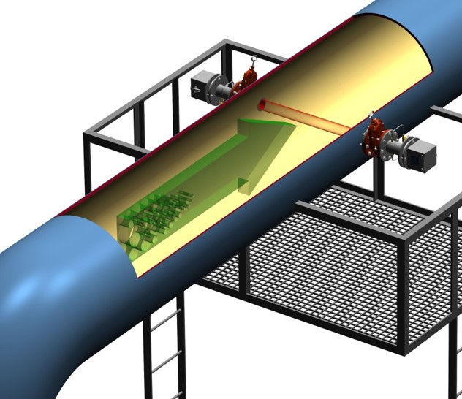
EPA Compliance
EPA 40 CFR 60 & 75
Subpart Ja
Refinery Sector Rule (RSR)
SCAQMD Rule 1118
NIST Traceable
API MPMS 14.0 Measurement of Flow to Flares

Optical Scintillation
OFS is based on Optical Scintillation (light Fluctuation) and Temporal cross-correlation (i.e. Time of Flight). OFS uses a partially coherent LED and works by clocking the speed of the shadows that pass by the Optical detectors.

OFS placement
Can be located near or in bends/elbows in some applications.
Can be installed in an x pattern on verticle stacks
Horizontal applications can add multiple lines if required

Optical Flow Sensors (OFS)
Air/Gas flow meters
No matter what your need there is an OFS Model for Every application
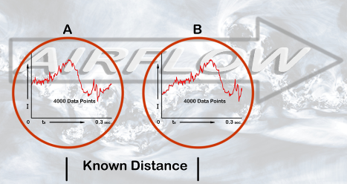
Measurement technique – Optical Scintillation (OSI Patenetented)
Available Ranges:
- 0.1 to 40 M/sec (OFS-2000)
- 0.03 to 100 m/sec (OFS-2000W)
- 0.03 to 170 M/sec (OFS-2000F)
Accuracy (abolute) ± 0.1 m/sec basic – or - ± 2 % of reading whichever is greater
Repeatability (relative)) ± 0.1 m/sec basic – or –
± 1 % of reading whichever is greater
Long Term Drift: less than 1% per year
Response Time 3 to 600 seconds user selectable
Automatic Calibration 2 or 3 point user selectable internal or on external command
Sensor Health Monitoring Continuous Self-test of valtages, performance, optics, etc
I/O; Two 4-20 mA outputs, RS 232 Seial IO, Modbus RTU. Two 4-20 mA inputs (temperature & pressure)

Flow Meter Performance
OFS Applications Include:
Flare Stacks, Incinerators, Cat Crackers, Thermal Oxidizers. Terminal Loading Stations. Boilers, CEMS, Secondary Air, Primary Air, Air Assit Lines, Sulphur Recovery Units (SRU), FCCU, Bag Houses, Combustion Air Flow, Wet Scrubbers, Supplimental Lines, SCR and so much more!
OFS-2000
Our basic stack air flow sensor for use in CEMS , Air Assit and any industrial applications. Robust accurate, reliable, low maintenance. 0-40 m/sec

OFS-2000F
Expanded scale and rapid response. The F model was developed for flare stacks where expanded velocity scale, wider flow media temperature range and quicker response times are required. .03-170 m/sec

OFS-2000W
Our most versitile flow sensor model. The W model is equiped with Automatic Gain Control (AGC) to handle transient variation in flow opacity. Widely used on wet scrubbers, Bag houses, SCR and Secondary air ducts the OFS-2000W is capable of handling the challenges of more demanding applications with entrained / suspended liquid droplets

The OFS reciever uses two Optical Detectors and takes 4000 data points every .03 seconds and then measures the instantaneous average velocity along a strait line, which streaches across the pipe, stack or duct. OFS measures the ACTUAL velocity in feet per second.

At it’s core OFS is a velocity sensor. However, all OFS models come with two 4-20 mA inputs to accept readings from smart temperature and pressure sensors. Note this is not a requirement for measurement but will enable OFS to report Standard Volumetric Flow. You can use plug in number for density or pair it with a concentration analyzer for Mass Flow.
Optical Detectors & Standard Volumetric Flow
OFS Benefits

Environmental Compliance
Combustion Air flow
On-site Training
Easy to Install
Can use Hot Tap to install
High Hydrogen is Not a Problem
Media containment

2 Metropolitain Court
Suite 6
Gaithersburg, MD 20878
Phone 301.963.3630
info@opticalscientific.com
www.opticalscientific.com

